**PLT**

**Phase Two Report**

**Mayar El Mahdy 4639**

**Al Zahraa Emara 4558**

* **Class Diagram Figure:**

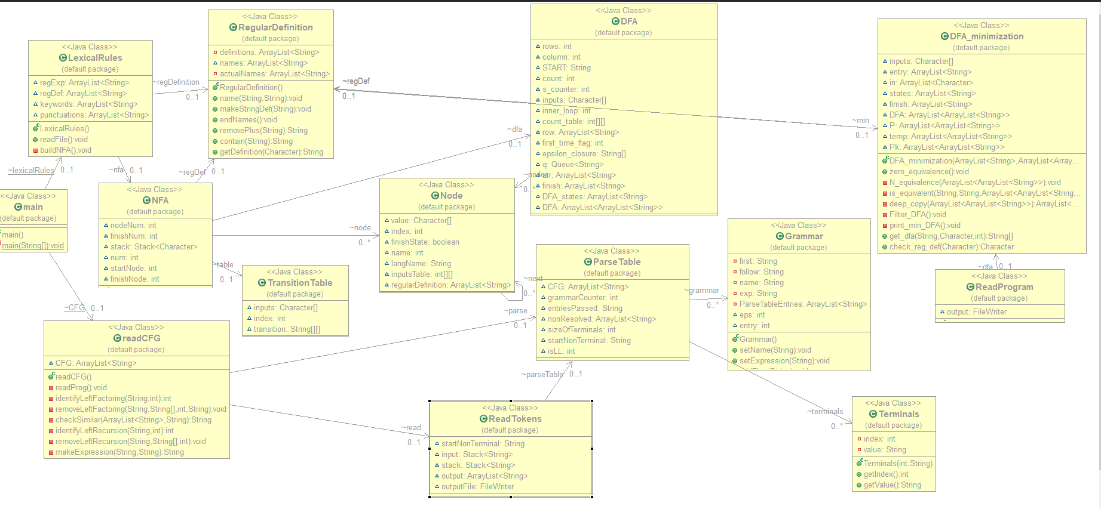

The class diagram consists of both classes used in phase one and two.

* **Data Structures:**

**Stack :** It was used in phase two when applying the parse table and the tokens (from phase one as input) , to determine if it is accepted to the CFG or not . –In **ReadTokens** class --

**ArrayList :** It was used several times

**-**In class **ReadCFG** , an arraylist is used to store each CFG read from the input file.

**-** In class **ReadTokens ,**an arraylist was used to store the output of terminals that were accepted by the CFG.

* **Algorithms and techniques:**
* **Used tools:**
* **Functions Explanation:**

**-Left Factoring:**

**1-Identify it:**

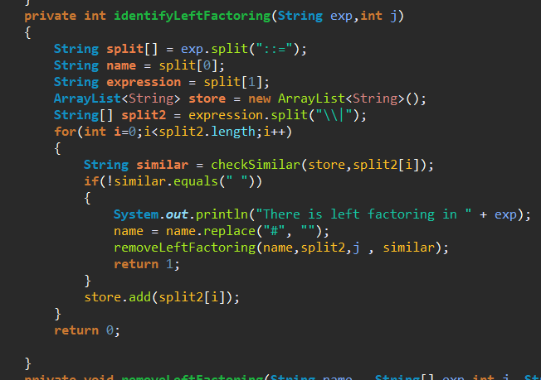

This function is used to identify if the grammar has Left factoring or not, so it begins by splitting the CFG with the name and the definition , then checks if there are any similar terminals/nonterminals between the OR

Ex: # A ::= ‘a’ B | ‘a’ C ,, there is left factoring , similar = ‘a’

The array list called **store** stores the definitions that were checked before so we can check for similarties in the function **checkSimilar**

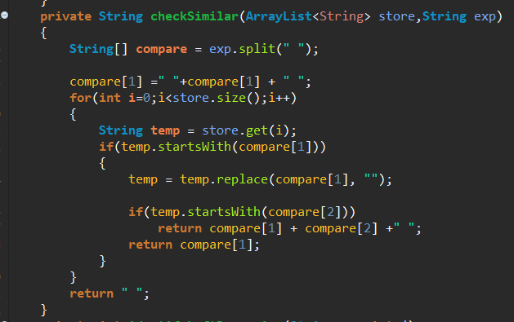

This function checks for similarities between the previous and the definition I have now , So we check for max the first two terms if there are similar or not

First we check **compare[1]** if there is a match ! then check **compare[2]**

Return the common term .

Else return blank String –no similarity—

If there is similarities then go to function **removeLeftFactoring**

**2-Remove Left Factoring :**

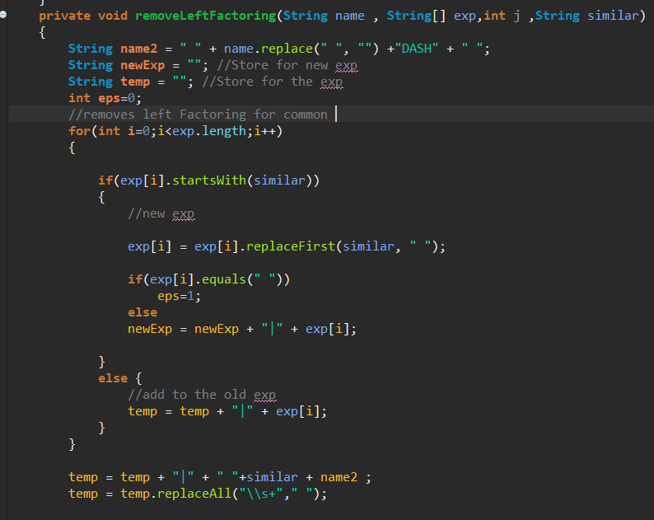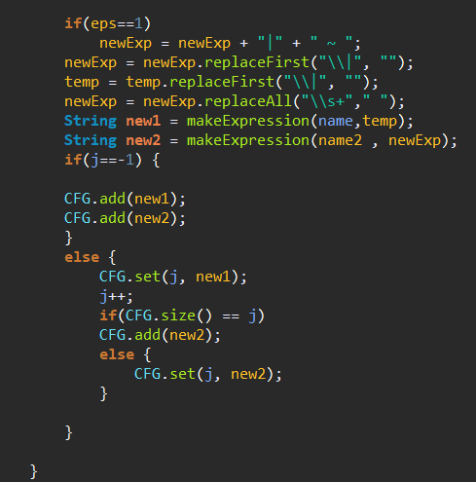

This function is responsible for removing the left factoring and making two new CFG expressions rather than one .

The algorithm is rather simple , it splits the CFG when it sees ( | ) then checks if the similar String matches it , if yes then add in **newExpression** the expression without the common similar

Else add in the expression normally to **temp**

At the end you will have two CFG expressions

Temp will take the name of the original CFG

New expression will take the name of the original CFG + add “DASH” to it .

**-Left Recursion:**

**1-Identify it:**

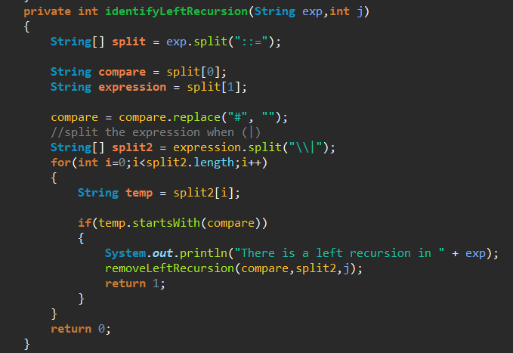

Identify the left recursion by checking if the name of CFG occurs as the start of the definition , split the definition each ( | ) and check the start String .

**2-Remove Left Recursion :**

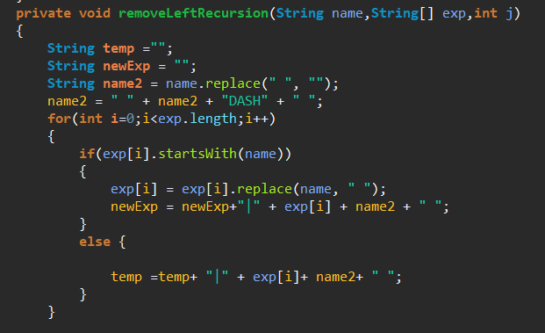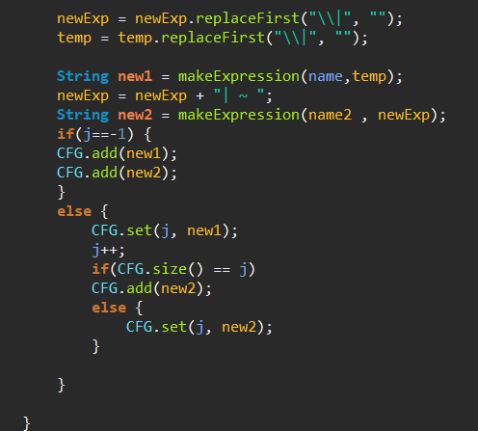

Removing the left recursion algorithm is to take the splitting string ( | ) then checking each String if it starts with the name of the CFG then add it to the new Expression (after removing the occurrence of its name)

Else then add it to temp and also add the new name to it ( new name is original CFG name + DASH)

Then add the new Expression and temp to the CFG as we did in the left factoring.

* **Assumptions:**
* **Sample Runs:**

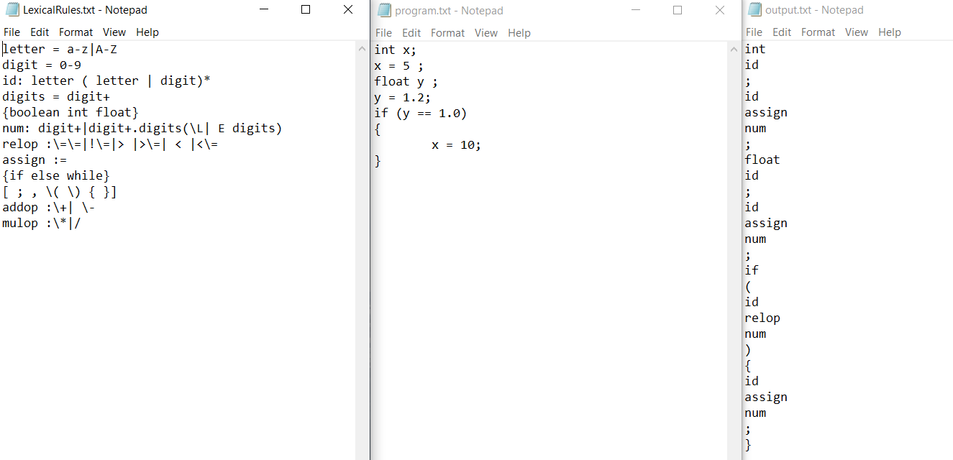

Figure: The three text files from phase one.

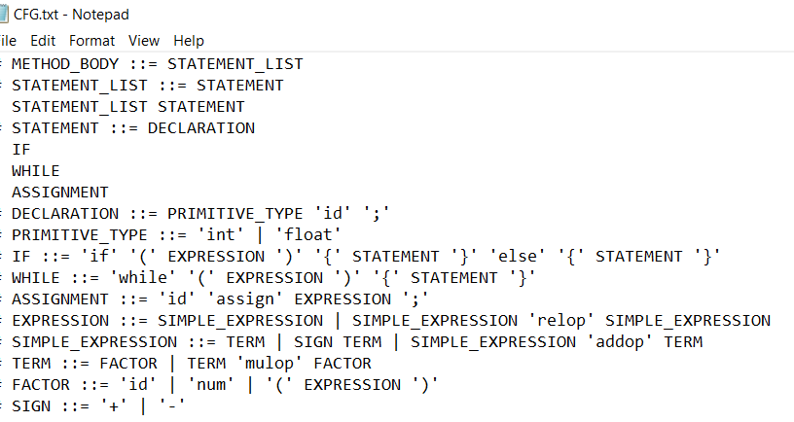

Figure: the CFG text file.

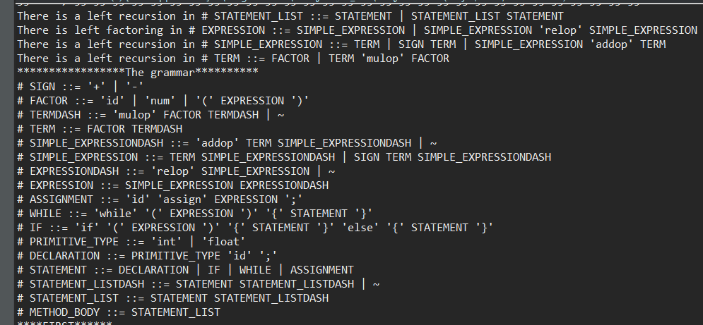

Figure: The grammar in runtime , there was Left recursion & Left factoring.

Note that the new grammar is printed from bottom to top

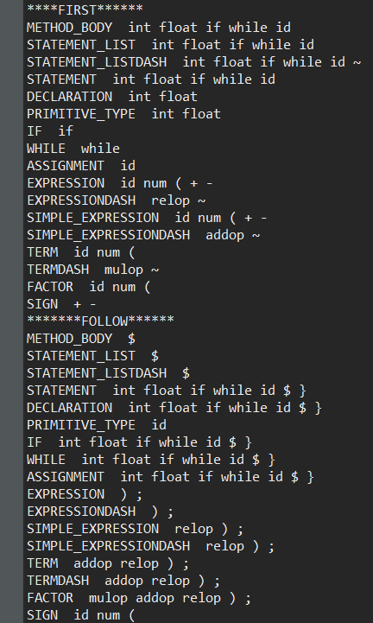

Figure: First & follow , Note that ‘~’ means epsilon.

The **parsing table** was too big to fit the screen so I divided it as follow :

|  |  |
| --- | --- |
|  |  |

Each Non terminal with it’s entry in the parse table is printed alone , the ‘-’ sign means that nothing is present when this terminal is the input and ‘~’ means epsilon .

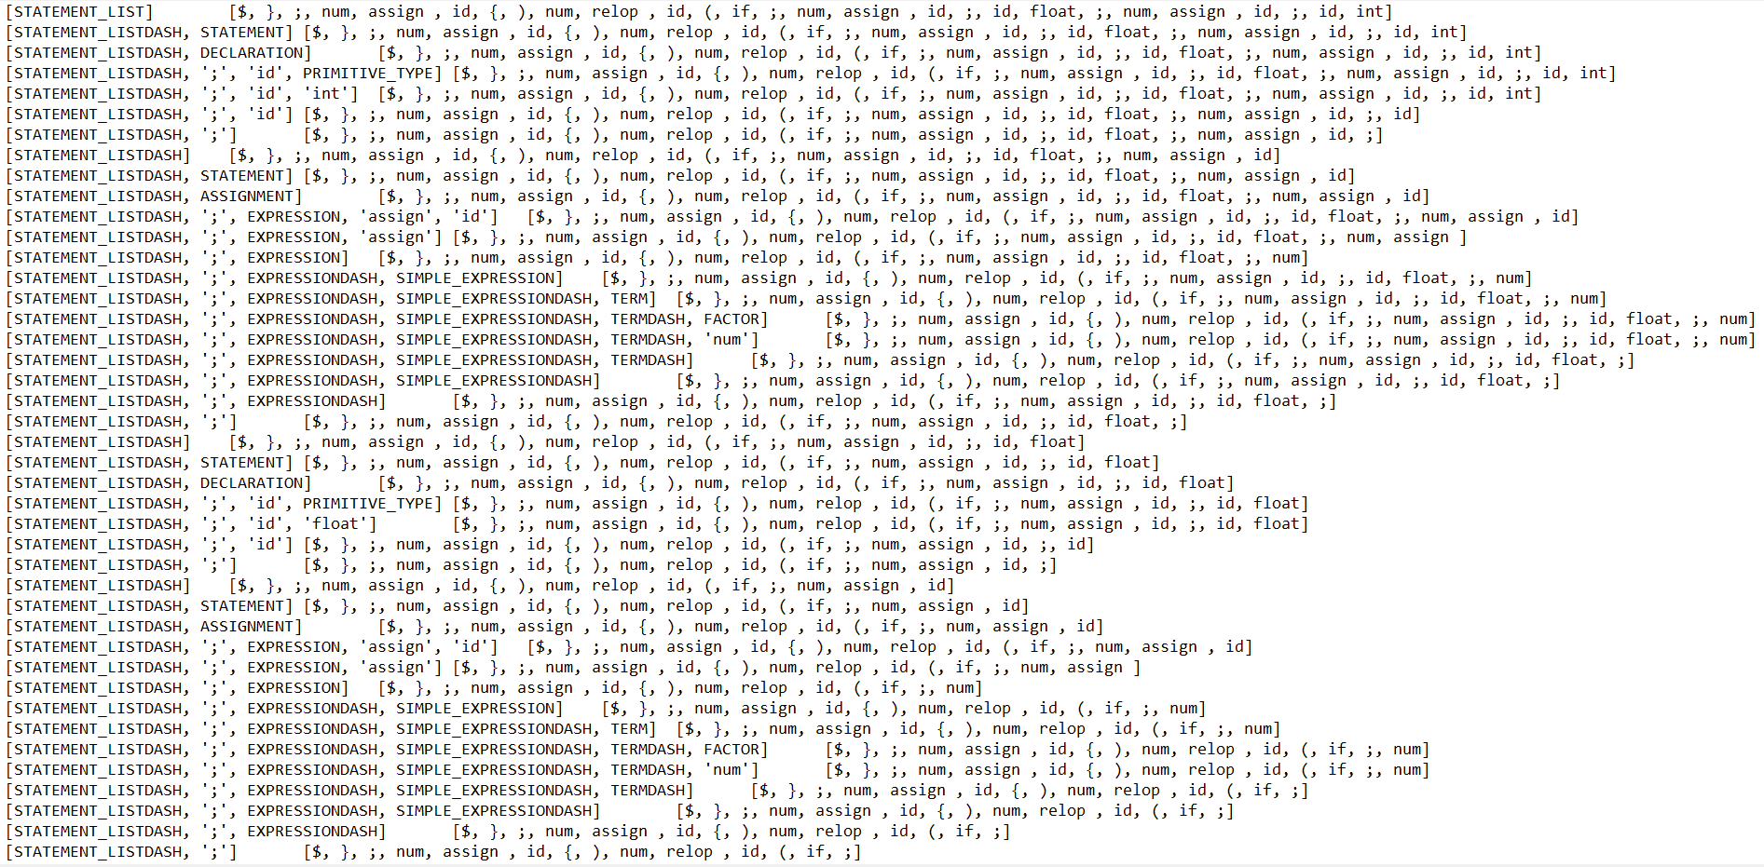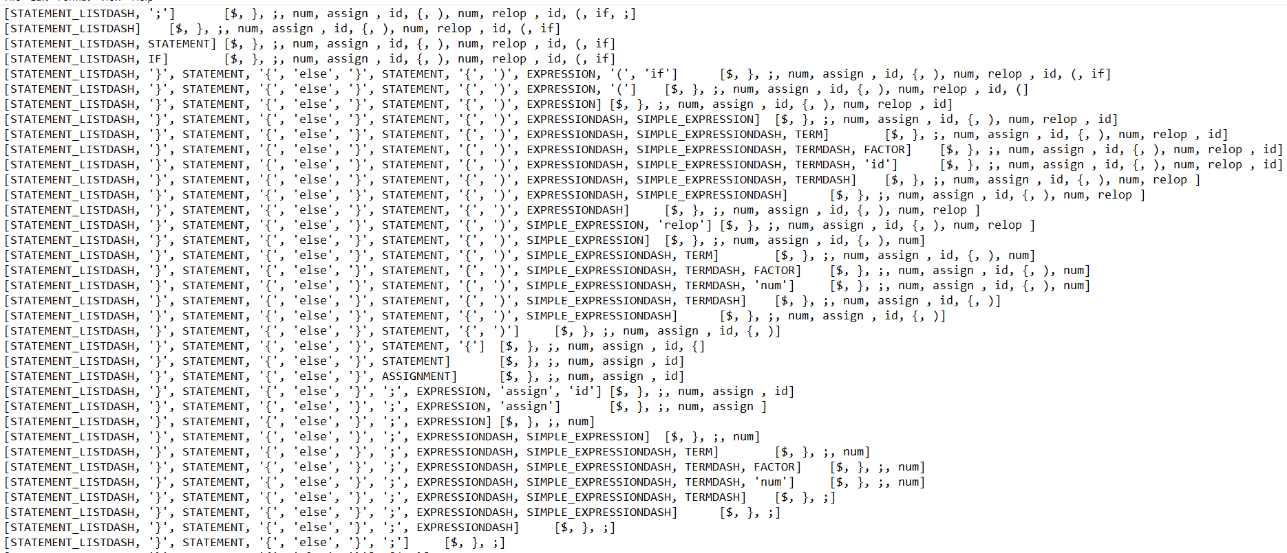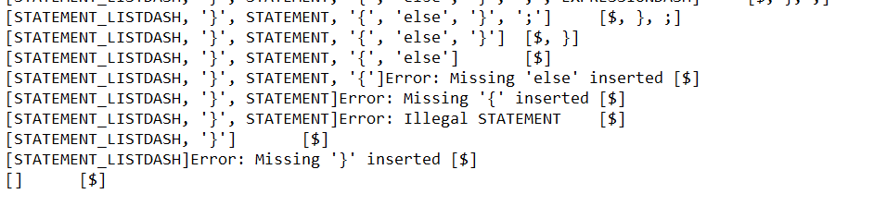

Here you can clearly see the method used in errors :Panic mode ,When else was not found in if statement.